Experiment - 6

Aim :
Write your own MATLAB function “mycirconv” to compute circular convolution of two sequences.

Theory:
Two real N-periodic sequences x(n) and h(n) and their circular or periodic convolution sequence y(n) is also an N- periodic and given by,
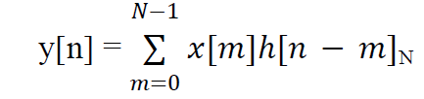
Circular convolution is something different from ordinary linear convolution operation, as this
involves the index ((n-m))N, which stands for a “modulo-N‟ operation. Basically both type of
convolution involve the same six steps. But the difference between the two types of convolution
is that in circular convolution the folding and shifting (rotating) operations are performed in a
circular fashion by computing the index of one of the sequences with „modulo-N‟ operation.
Either one of the two sequences may be folded and rotated without changing the result of circular convolution. If x (n) contain L no of samples and h (n) has M no of samples and that L > M, then perform circular convolution between the two using N=max (L,M), by adding (L-M)no of zero samples to the sequence h (n), so that both sequences are periodic with number

IN LAB EXERCISE

Write your own MATLAB function “mycirconv” to compute circular convolution of two sequences.

function result = mycirconv(mode,sig1,sig2)
if mode == 1
N = length(sig1);
M = length(sig2);
sig1 = [sig1,zeros(1,M-1)];
sig2 = [sig2,zeros(1,N-1)];
disp('Linear convolution using circular convolution user defined function = ')
else
disp('Circular convolution using user defined function = ')
end
for i = 1:length(sig1)
for j=1:length(sig2)
w(i,j) = (exp(-1i*2*pi/(length(sig1)))).^((i-1).*(j-1));
end
end

SIG1 = w*transpose(sig1);
SIG2 = w*transpose(sig2);
result = inv(w)*SIG1.*SIG2);
disp(result)
figure;
subplot(2,1,1)
stem(result)
title('Circular Convolution 22102071')
xlabel('Time axis')
ylabel('Amplitude')
end

POSTLAB EXERCISE :

Using your function “mycirconv” , evaluate and interpret the results of the following questions:
Q 1. Find circular convolution of the following signals x(n)={1,2,1,2}, h(n)={4,3,2,1}
Q 2. Find circular convolution of the following signals x(n)={1,2,0,1}, h(n)={2,2,1,1}
Q3. Find circular convolution of the following signals x(n)={1,-1,1,1}, h(n)={1,2,3,4}
Q4. Find circular convolution of the following signals x(n)={1,3,4,5}, h(n)={2,1,4,1}
Q 5. Find linear convolution of the following signals using circular convolution x(n)={1,2,4}, h(n)={2,5}
Q 6. Find linear convolution of the following signals using circular convolution x(n)={5,3}, h(n)={2,4,6}
%1
x1 = [1,2,1,2];
h1 = [4,3,2,1];
mycirconv(0,x1,h1);
disp('Circular convolution using in-built function = ')
disp(cconv(x1,h1,4))
subplot(2,1,2)
stem(cconv(x1,h1,4))
title('Cirular Convolution 22102071')
xlabel('Time axis')
ylabel('Amplitude')

%2
x2 = [1,2,0,1];
h2 = [2,2,1,1];
mycirconv(0,x2,h2);
disp('Circular convolution using in-built function = ')
disp(cconv(x2,h2,4))
subplot(2,1,2)
stem(cconv(x2,h2,4))
title('Circular Convolution 22102071')
xlabel('Time axis')
ylabel('Amplitude')

%3
x3 = [1,-1,1,1];
h3 = [1,2,3,4];
mycirconv(0,x3,h3);
disp('Circular convolution using in-built function = ')
disp(cconv(x3,h3,4))
subplot(2,1,2)
stem(cconv(x3,h3,4))
title('Circular Convolution 22102071')
xlabel('Time axis')
ylabel('Amplitude')

%4
x4 = [1,3,4,5];
h4 = [2,1,4,1];
mycirconv(0,x4,h4);
disp('Circular convolution using in-built function = ')
disp(cconv(x4,h4,4))
subplot(2,1,2)
stem(cconv(x4,h4,4))
title('Circular Convolution 22102071')
xlabel('Time axis')
ylabel('Amplitude')

%5
x5 = [1,2,4];
h5 = [2,5];
mycirconv(1,x5,h5);
disp('Linear convolution using in-built function = ')
disp(conv(x5,h5))
subplot(2,1,2)
stem(conv(x5,h5))
title('Circular Convolution 22102071')
xlabel('Time axis')
ylabel('Amplitude')

%6
x6 = [5,3];
h6 = [2,4,6];
mycirconv(1,x6,h6);
disp('Linear convolution using in-built function = ')
disp(conv(x6,h6))
subplot(2,1,2)
stem(conv(x6,h6))
title('Circular Convolution 22102071')
xlabel('Time axis')
ylabel('Amplitude')

Output:

1.

Circular convolution using user defined function =
14.0000 + 0.0000i
16.0000 + 0.0000i
14.0000 - 0.0000i
16.0000 - 0.0000i

Circular convolution using in-built function =
14 16 14 16
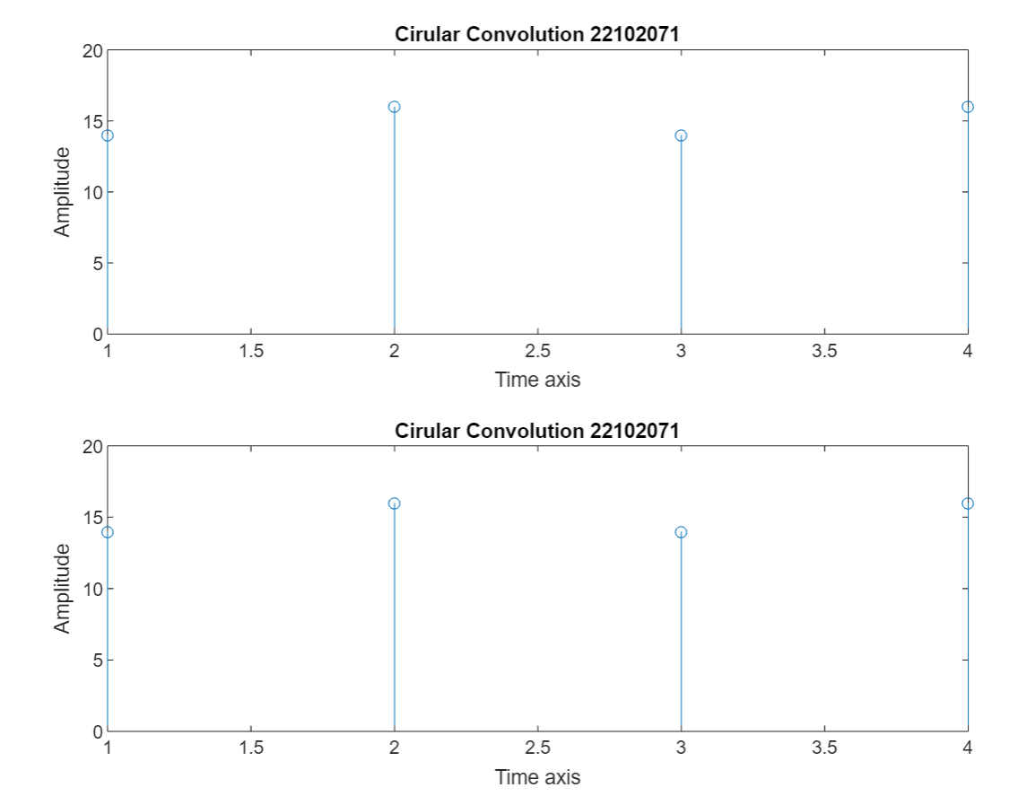

2.
Circular convolution using user defined function =
6.0000 + 0.0000i
7.0000 - 0.0000i
6.0000 - 0.0000i
5.0000 - 0.0000i

Circular convolution using in-built function =
6 7 6 5

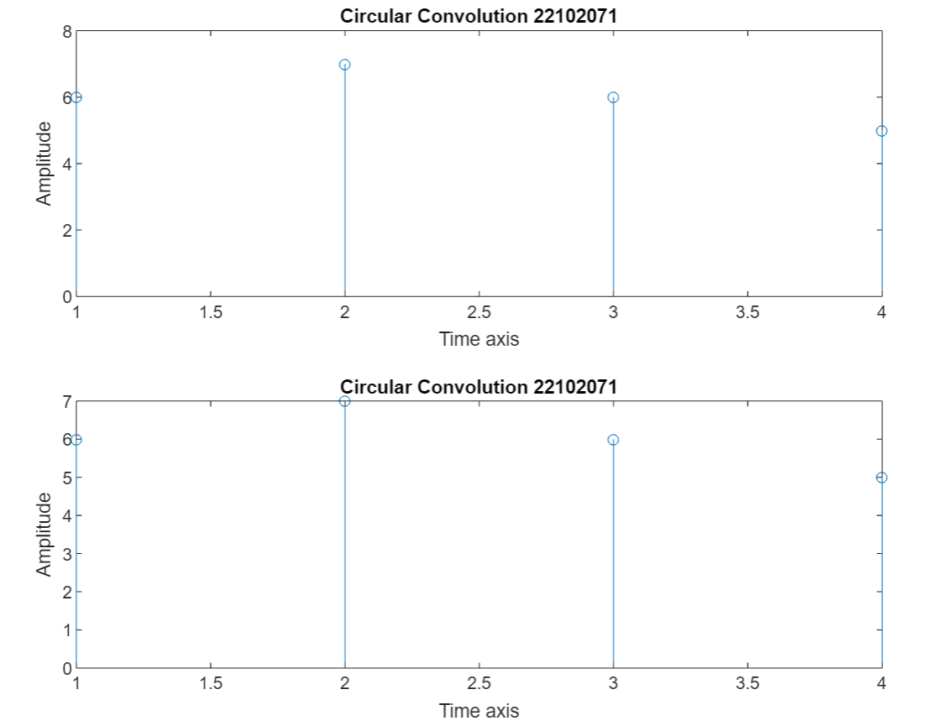
3.
Circular convolution using user defined function =
2.0000 - 0.0000i
8.0000 + 0.0000i
6.0000 + 0.0000i
4.0000 - 0.0000i

Circular convolution using in-built function =
2 8 6 4
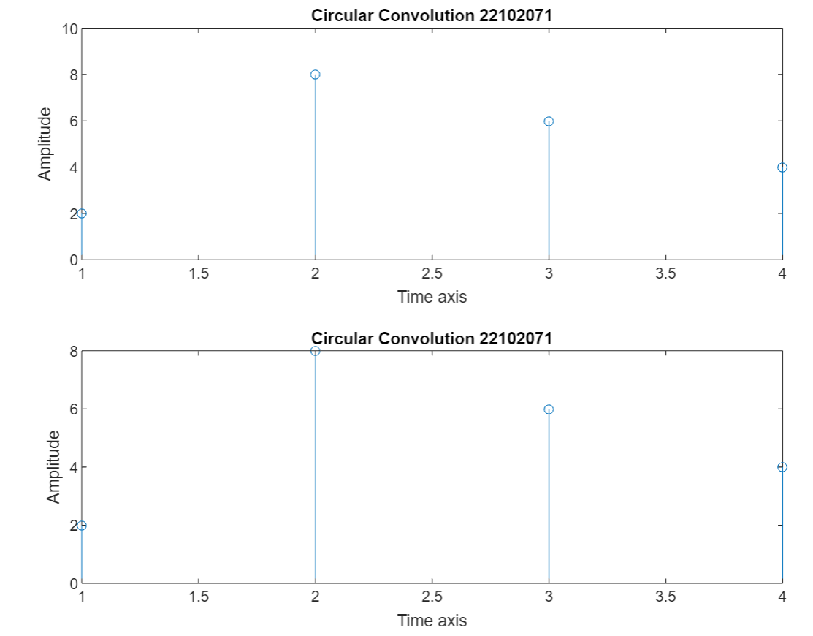
4.
Circular convolution using user defined function =
26.0000 + 0.0000i
31.0000 + 0.0000i
20.0000 - 0.0000i
27.0000 - 0.0000i

Circular convolution using in-built function =
26 31 20 27
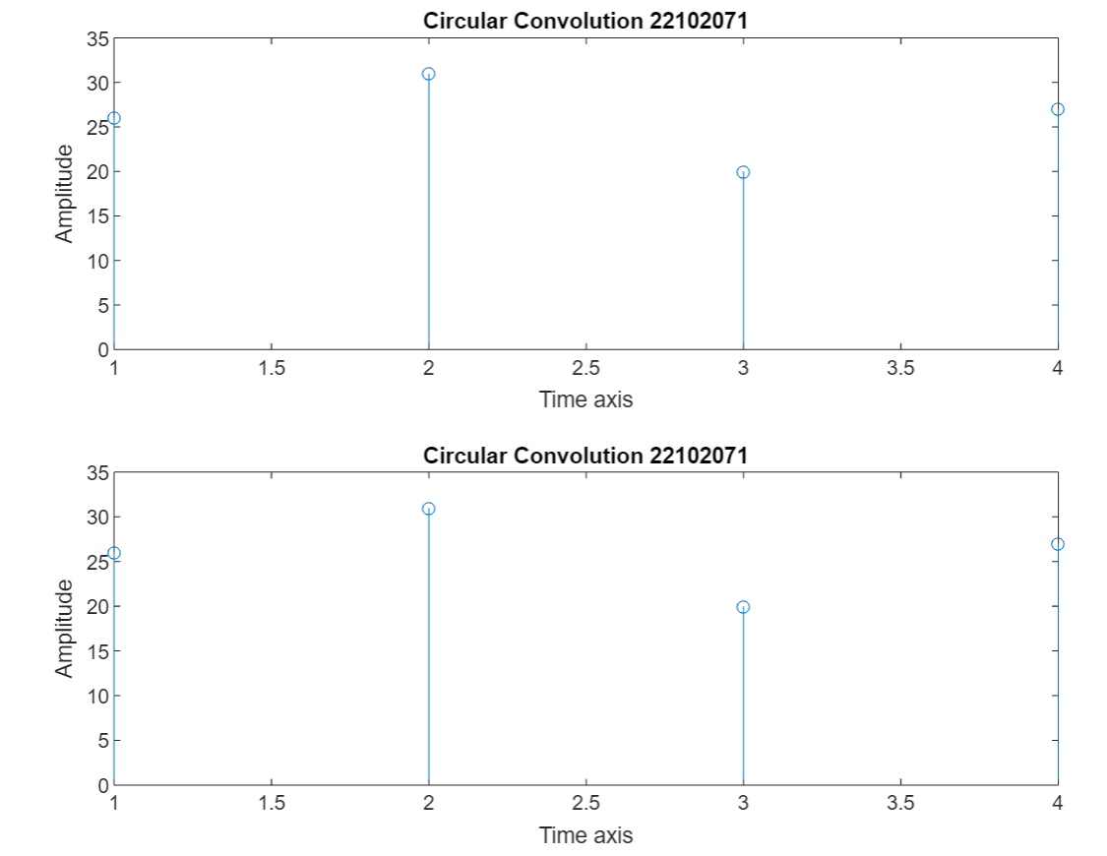
5.
Linear convolution using circular convolution user defined function =
2.0000 - 0.0000i
9.0000 + 0.0000i
18.0000 - 0.0000i
20.0000 + 0.0000

Linear convolution using in-built function =
2 9 18 20
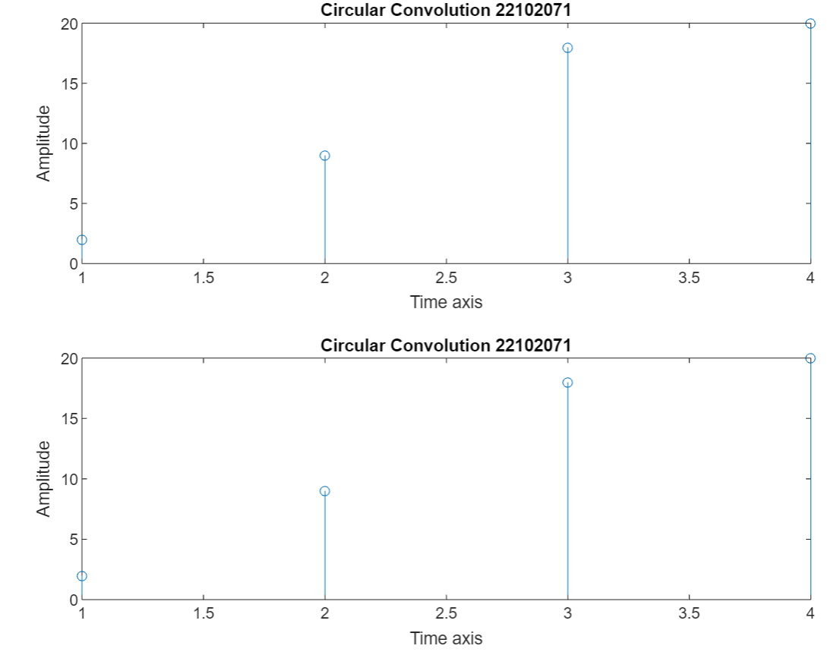
6.
Linear convolution using circular convolution user defined function =
10.0000 - 0.0000i
26.0000 + 0.0000i
42.0000 - 0.0000i
18.0000 + 0.0000i

Linear convolution using in-built function =
10 26 42 18
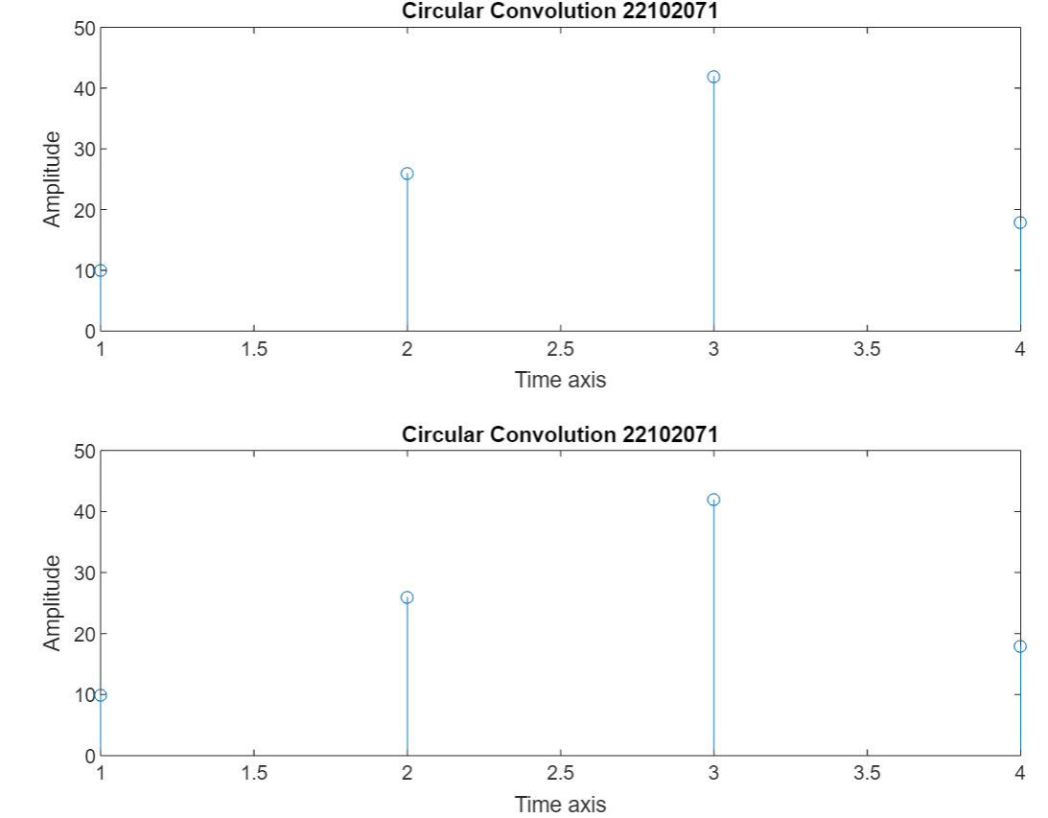

LEARNING OUTCOME:
- Understanding the process of circular convolution.
- Learning the code required to calculate the circular convolution.
- Recalling the process of linear convolution using circular convolution

